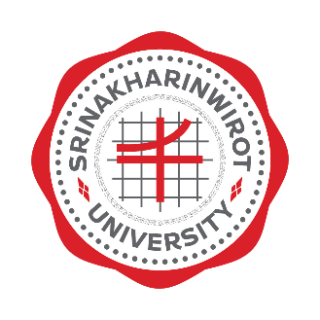
Memorandum of Understanding
between

( University)

and

SRINAKHARINWIROT UNIVERSITY
_____________________________

() University, (Country) and Srinakharinwirot University, Bangkok, Kingdom of Thailand are interested in bringing a more global dimension to their curricula and research.
The Memorandum of Understanding (MoU), therefore, is made as a gesture to goodwill between the two universities and mutual benefit through the cooperative effort in the following areas:
- Exchange of student for joint degree, and non-degree curricula
- Exchange of faculty members and staff
- Exchange of academic materials and other information
- Joint research activities and publications
- Joint performance and exhibition activities
- Participation in seminars/ workshops and academic meetings
- Participation in special short-tern academic and cultural programs

This MoU shall be valid for five years from the date of signing. Revision or renewal of this cooperative link is subject to mutual consent of both parties.

It is expected that this MoU will lead to other more specific collaborative MoU between the two institutions. Details of the implementation of any particular activities resulting from this MoU shall be negotiated between the two universities as such specific cases arise.

Either party may terminate the MoU by written notification signed by the appropriate official of the party initiating the notice. Such notification must be received by the other party at least six months prior to the effective date of termination.

This MoU serves as the intention of both parties to work together to promote academic and educational linkage. It does not have any legal binding on the part of the universities involved.

Signed for and on behalf of Signed for and on behalf of
() University Srinakharinwirot University
by by

_____________________________ _____________________________
(Name) Assoc. Prof. Dr. Somchai Santiwatanakul
(Position) President

Date:____________________________ Date:_______________________

